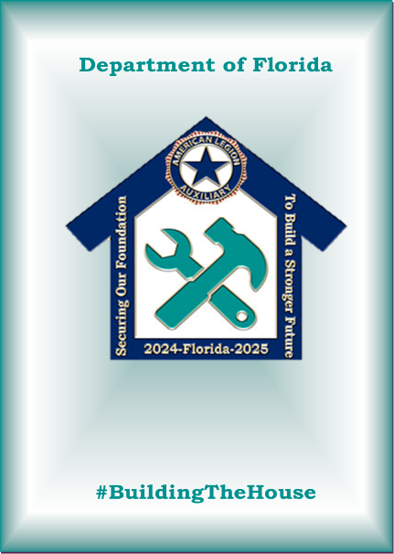

**Unit Guide Updates**

Cheryl Adams - 16th District President -zip code 33763

Mary Fish - 12th District President change phone # to cell 321-544-8487

Education Chairman - Stacy Cusano - street is Liberty Hill Rd., Hartwell, GA 30643

C&B email address is [Cbylaws@alafl.org](mailto:Cbylaws@alafl.org)

Risk & Compliance email is [Risk@alafl.org](mailto:Risk@alafl.org)