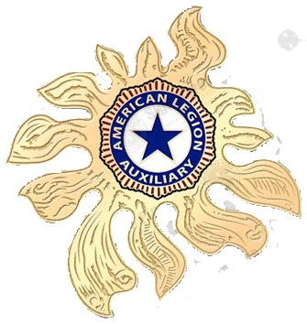
AMERICAN LEGION AUXILIARY
DEPARTMENT of FLORIDA

CORDIALLY INVITES YOU
DEPARTMENT WORKSHOP
September 8 – 10, 2017
WYNDHAM Lake Buena Vista Resort
1850 Hotel Plaza Blvd Orlando, FL 32830

FRIDAY 7:00 PM CHAIRMEN AND OFFICERS Meet and Greet
MEMBERSHIP TEAM SOCIAL
SATURDAY 9:00 AM PROGRAM PRESENTATIONS
SATURDAY 12:00 Noon LUNCH will be Available $TBD
SATURDAY 1:30 PM PROGRAM PRESENTATIONS
* * *EVERYONE IS WELCOME * * *
Door Prizes Awarded * * * Gift to ALL Attendees
COME JOIN THE FUN!!!

