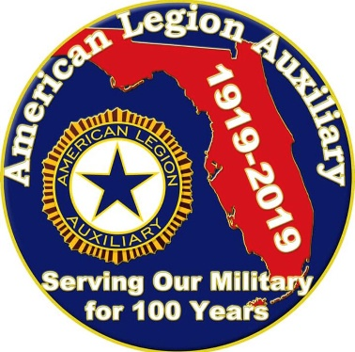

Unit Leadership Mid-Year Program Reporting

2019 - 2021
Florida ALA Strong!!!

Unit Chairman ______________________________________ Unit # _______
Chairman’s Address ___________________________________________________________
Phone # ___________________________ E-mail Address: _________________________

Did your Unit offer the National Junior Leadership Course? _____________
Did your unit distribute, explain & utilize the following “How to Sheets”?
How to Utilize a Member Data Survey Form _____________
How to Conduct a Unit Meeting _____________
How to Lead a Small Unit _____________
How to Grow Leadership Capacity, Nurturing a Culture of Goodwill _____________
Did your unit follow basic parliamentary procedure during meetings? _____________

Send this Unit Mid-Year Report form and narrative, to the District Chairman no later than December 1, 2020.

Narratives
- Did unit members attend district trainings? Which trainings? How many members attended? Were the trainings implemented in your unit?
___________________________________________________________________________

___________________________________________________________________________

___________________________________________________________________________

___________________________________________________________________________

- Did your unit hold additional training sessions? What were the topics? How many members attended?
___________________________________________________________________________

___________________________________________________________________________

___________________________________________________________________________

___________________________________________________________________________

- Did your unit hold a training on nurturing a culture of goodwill? How many attended? Was it well received? Please attach copy of training agenda.
___________________________________________________________________________

___________________________________________________________________________

___________________________________________________________________________

___________________________________________________________________________

- Did your unit work on grooming members to excel in their current roles while preparing to advance to higher levels within the organization, developing the leader within? If so, how was it done and what were the outcomes?

___________________________________________________________________________

___________________________________________________________________________

___________________________________________________________________________

___________________________________________________________________________

