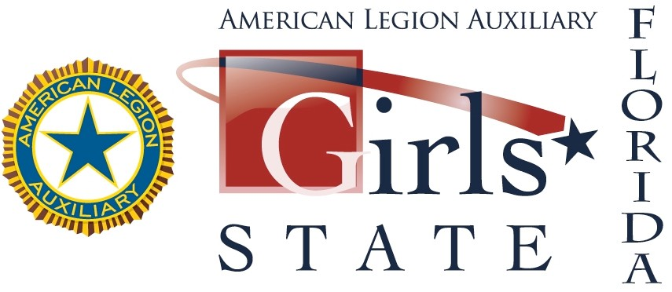
Girls State Over-Quota Unit Registration

Completed registration forms for the 2021 session of the Florida Girls State program are due to The American Legion Auxiliary Department of Florida no later than January 31, 2021. The non-­‐refundable registration fee is $400 per delegate. Should your delegate be unable to attend, an alternate will be sent in their place. Please note: Unit obligations must be paid and unit must be at charter strength (10 paid senior members) to register for Girls State. Only units who reached the 100% goal in membership by January 31, 2021 are entitled to apply for Over-Quota delegates. Quota amounts and fees cannot be included with regular registration fees. Girls State dates are June 9-17, 2021
DO NOT SELECT A DELEGATE UNTIL YOU RECEIVE A NUMBERED APPLICATION FOR ONLINE REGISTRATION FROM DEPARTMENT HEADQUARTERS. Over-Quota delegates are awarded on a first-come, first-serve basis.

Number of Delegates Requested:

Check number: Amount:
Is Department Holding Unit Money: ______ If so, how much: _________________

Please make check payable to: American Legion Auxiliary Department of Florida Girls State
P.O. Box 547917
Orlando, FL 32854-­‐7917
Unit Name:

Unit Number: District Number:

Unit Address:

Zip Code: City:

Unit Girls State Chairman: (only one name)

E-­‐mail Address: (only one address. Print legibly)

Daytime phone: Evening phone:

Office Use Only
Date Received:___________ Membership Amount:_____________ Number of Delegates Approved: _____
Date Delegate/Alternates Forms Mailed:__________

