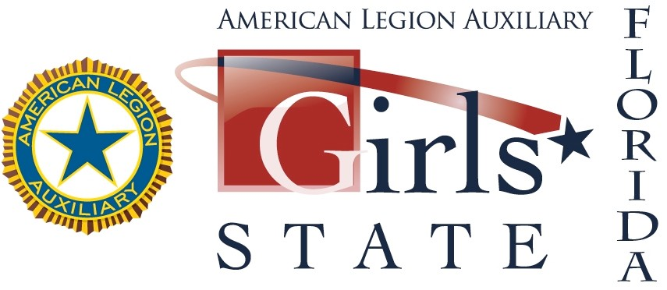
Girls State Unit Registration

Completed registration forms for the 2022 session of the Florida Girls State program are due to The American Legion Auxiliary Department of Florida no later than January 31, 2022. The non-­‐refundable registration fee is $400 per delegate. Should your delegate be unable to attend, an alternate will be sent in their place. Please note: Unit obligations must be paid and unit must be at charter strength (10 paid senior members) to register for Girls State.
Quota amounts and fees cannot be included with regular registration fees. Girls State dates are June 7-15, 2022

DO NOT SELECT A DELEGATE UNTIL YOU RECEIVE A NUMBERED APPLICATION FOR ONLINE REGISTRATION FROM DEPARTMENT HEADQUARTERS.

Number of Delegates Requested:

Check number: Amount:

Please make check payable to: American Legion Auxiliary Department of Florida Girls State
1912A Lee Road
Orlando, Fl. 32180
Unit Name:

Unit Number: District Number:

Unit Address:

Zip Code: City:

Unit Girls State Chairman: ___ (only one name)

E-­‐mail Address: (only one address. Print legibly)

Daytime phone: _______ Evening phone:

Office Use Only
Date Received:___________ Membership Amount:_____________ Number of Delegates Approved: _____
Date Delegate/Alternates Forms Mailed:__________

