Flag Folding Procedure

The traditional method of folding the flag is as follows:
(A) Straighten out the flag to full length and fold lengthwise once.
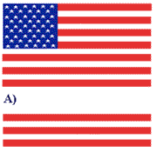
(B) Fold it lengthwise a second time to meet the open edge, making sure that the union of stars on the blue field remains outward in full view. (A large flag may have to be folded lengthwise a third time.)
(C) A triangular fold is then started by bringing the striped corner of the folded edge to the open edge.
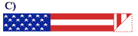
(D) The outer point is then turned inward, parallel with the open edge, to form a second triangle.
(E) The diagonal or triangular folding is continued toward the blue union until the end is reached, with only the blue showing and the form being that of a cocked (three-corner) hat.
