Fall Conference Poppy Contest
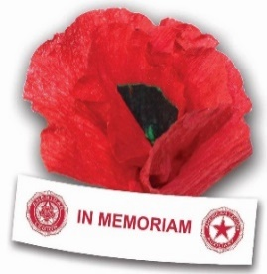

Design a Poppy Wall or Table Decoration

Not to exceed 12” X 12” X 12”

Bring to Fall Conference.

All entries will be displayed for raffle; all proceeds will be donated to Honor Flight

Judging will be based on number of raffle tickets deposited for each item.

