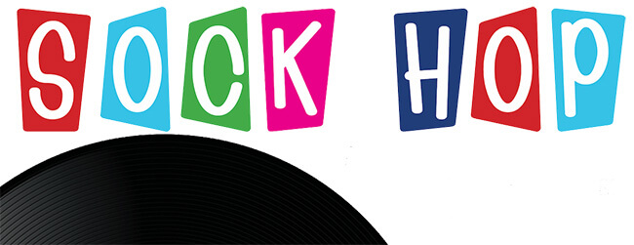

The American Legion Auxiliary & American Legion formally invites you to attend the
President & Commander’s Banquet

Saturday, November 4th, 2017
6:30 – 9:30 p.m.
Discovery Ballroom
Theme is “Sock Hop”
Entertainment: Patrick Gibson

Menu:
Soup of the Day
Chopped Romaine Hearts, Parmesan Cheese, and Herb Croutons
Pan Seared All Natural Chicken Breast, Chef's Roasted Mushrooms, Saltimbocca Sauce
Roasted Market Fish Piccata, Lemon and Capers
Cheese Tortellini, Blistered Tomato, Spinach, and Pesto Cream
Costume Contest so come dressed in your Sock Hop Best!!
Broccolini with Olive Oil and Lemon
Roma Pesto Focaccia
Chocolate Cream Cannoli
Ricotta Chocolate Chip Tart
Limited 150 people
Before October 20, 2017 - $35.00
Before November 1, 2017 - $40.00
At Fall Conference - $50.00

Complete and Return to: American Legion Auxiliary, P.O. Box 547917, Orlando, Fl. 32854

Name:_________________________________________________________________________________

Address:_______________________________________________________________________________

City: _______________________________ State: _______________________ Zip ___________________

Post/Unit _________________________________ Enclosed Check Amount $________ For _______ Tickets

