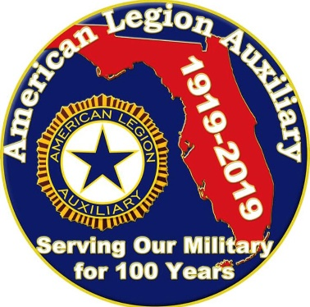

District Leadership Year-End Program Reporting

2019 - 2021
Florida ALA Strong!!!

District Chairman ______________________________________ District # _______
Chairman’s Address ___________________________________________________________
Phone # ___________________________ E-mail Address: _________________________

How many district members attended National Mission Training? _____________
How many Units offered the National Junior Leadership Course? _____________
How many units distributed, explained & utilized the following “How to Sheets”?
How to Utilize a Member Data Survey Form _____________
How to Conduct a Unit Meeting _____________
How to Lead a Small Unit _____________
How to Grow Leadership Capacity, Nurturing a Culture of Goodwill _____________
How many units follow basic parliamentary procedure during meetings? _____________

Send this District Year-End Report form and narrative, along with a copy of each Unit’s Year-End report to the Department Chairman no later than April 15th, 2021.

Narratives
- What District trainings were held for Units? What topics were presented?
___________________________________________________________________________

___________________________________________________________________________

___________________________________________________________________________

___________________________________________________________________________

- Number of members attending these trainings, did you require feedback concerning what they learned, how this training will improve their ability to lead, and what trainings they would like to attend in the future? Were suggestions implemented?
___________________________________________________________________________

___________________________________________________________________________

___________________________________________________________________________

___________________________________________________________________________

- Did you hold training on nurturing a culture of goodwill? How many attended? Was it well received? Please attach copy of training agenda.
___________________________________________________________________________

___________________________________________________________________________

___________________________________________________________________________

___________________________________________________________________________

- Did your District and units within your district work on grooming members to excel in their current roles while preparing to advance to higher levels within the organization, developing the leader within? If so, how was it done and what were the outcomes?

___________________________________________________________________________

___________________________________________________________________________

___________________________________________________________________________

___________________________________________________________________________

