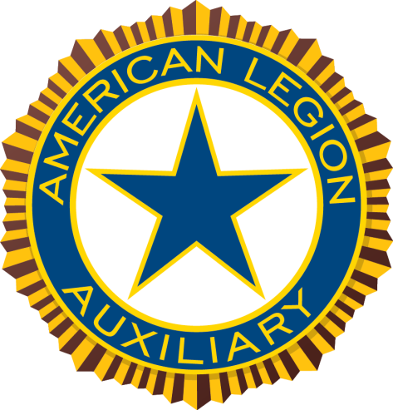

The American Legion Auxiliary Emblem

The emblem of the American Legion Auxiliary is your badge of distinction and honor. It stands for God and Country and the highest rights of man. It consists of several parts, and each part has a meaning. The rays of the sun that form the background stand for the principles of the American Legion Auxiliary, for the Loyalty, Justice, Freedom and Democracy; dispelling the darkness of violence, strife and evil. The unbroken circle of blue represents Unity and Loyalty. The field of white exemplifies the hope of Freedom. The star of blue is the emblem of service in war; it is no less the emblem of service in time of peace.
The emblem of the American Legion Auxiliary is the emblem of Americanism. As members of the American Legion Auxiliary, we must preach and teach principles of Americanism. Let us not forget that to each generation comes it patriotic duty and that upon your willingness to sacrifice and endure as those before you have sacrificed and endured, rests the hope of the nation.

