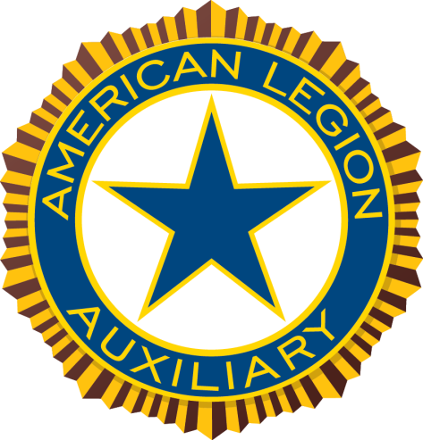

American Legion Auxiliary
Department of Florida

Sergeant-at-Arms

Cheryl Adams, Dept. Sergeant-at-Arms
Dee Touhey, Dept. Asst. Sergeant-at-Arms

2018 – 2019

Congratulations on being elected to the position of Sergeant-at-Arms for your District / Unit. The positions of Sergeant-at-Arms and Assistant Sergeant-at-Arms are extremely important to our organization.
Your first responsibility is to preserve order at all meetings of the District / Unit and to perform such other duties as requested by the President.
You are the first person and impression that members and guests encounter at a meeting. Please keep in mind that as Sergeant-at-Arms your duties apply to District / Unit meetings and special Auxiliary functions only. It is not your responsibility to keep order in your Post home.
Please remember the two “P’s”. Always be polite and pleasant.
The following are quick tips to assist you in performing the duties of Sergeant-at-Arms and Assistant Sergeant-at-Arms:
- Your title is Sergeant or Assistant Sergeant-at-Arms. If you remember that arms are at your side, you should be able to remember the proper term.
- The Sgt.-at-Arms should be properly attired at all Unit or District meetings and events. No jewelry is to be worn, except a watch, ring, and Auxiliary pin.
- The Auxiliary or officer pin should be worn over the heart and beneath the American Flag pin.
- No other pins are to be worn on the left side. At no time should the Auxiliary pin or the American Flag pin be used to fasten a scarf, tie, etc.
- A corsage may be worn, but should not cover the American Flag pin. If this is the case, the corsage should be moved to the other side of your blouse and be lower than the American Flag pin.
- The Sgt.-at-Arms and Asst. Sgt.-at-Arms should arrive at least Thirty (30) minutes prior to the meeting time.
- It is their duty to see that all materials, i.e. gavel, bell, bible, table, flags, etc. are in their proper place.
- When advancing the colors, always make sure the Eagles are facing forward with the American flag carried straight up and the Auxiliary banner slightly dipped.
- After posting colors, step back and render a right-hand salute over your heart. When retrieving the colors, you should salute before removing the flags simultaneously.
- In Florida the space between the flags is considered “Hallowed Ground” and should not be broken. Any notes or visitors to the podium should be taken to side where the Auxiliary banner is posted.
- When escorting guests offer your right arm and advance them to the flag or banner side. Legionnaires and S.A.L. always advance the podium on the American flag side. Stop before the flag and give a hand salute in unison with the person(s) you are escorting. Don’t assume all women approach on the Auxiliary banner side – we have dual members.
- When having a joint function, such as installation, the person speaking from the podium addresses his or her Sergeant-at-Arms. Unit Presidents rely on their Unit Sergeant-at-Arms and District Presidents rely on theirs. This rule also applies to Legion and S.A.L.
  - NOTE: If the Unit President calls for her Unit Sgt.-At-Arms and they are not available, she can utilize the District Sgt.-At-Arms in her absence.
- Remind members that we are the American Legion Auxiliary and we NEVER cadence clap, even when Legionnaires and S.A.L. do. As ladies we clap or applaud as we would in any other situation.
- Never wrap the flag around the staff or allow it to touch the ground. If it should touch the ground, you DO NOT have to destroy it as long as the flag remains suitable for display even if washing or dry cleaning is required.
The above list is by no means inclusive of everything you can learn about the duties of Sergeant-at-Arms, protocol and flag etiquette. However, you can find the full Program Action Plan at the following website: alafl.org under “Programs”.
In this packet we have assembled a variety of information that we hope you will find interesting and useful as you fulfill your duties this year.
We encourage you to use this information to educate and promote the Auxiliary. Ideas to educate and promote are:
- Wear an American flag pin daily.
- Participate in or organize an Auxiliary Color Guard.
- Contact local schools to address a class on proper flag etiquette.
- With appropriate permission, demonstrate to your Post or Unit the proper process to advance, post, retrieve, fold and care for your colors.
- Become involved in community activities such as parades, dedications and ceremonies where the Auxiliary Banner can be displayed.
Good luck as you assume your responsibilities. If we can be of any assistance to you or your Unit, please contact us.

Sergeant-At-Arms | Asst. Sergeant-At-Arms
Cheryl Adams  1971 Albany Drive  Clearwater, FL 33763  (727) 748-5121  Sergeant-at-arms@alafl.org | Dee Touhey  1971 Albany Drive  Clearwater, FL 33763  (727) 215-7119  Asst.Sergeant-at-arms@alafl.org

