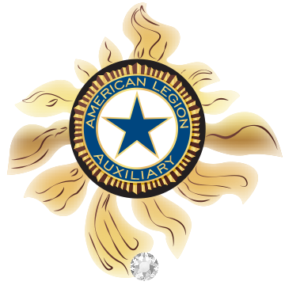
Children & Youth / Junior Activities 2017-2018
“Keep Focused On Our Future”

For the 2017-2018 Auxiliary year, President Treva “TK” Wildrick has chosen a theme of “Catching Rays, Creating Brighter Futures.” The traditional American Legion Auxiliary emblem is within the Sunburst. TK colors are patriot Red, White and true Blue. This Sunburst will serve as a constant reminder for us to keep focused on the goals and purposes that our organization embraces.
What could be more important than making sure that children are protected, cared for and supported, especially the children of our veterans and active duty military families? As Auxiliary members, we have so many ways to reach out to children and to be a constant reminder that we care about them.
Included in this Program Action Plan, are materials that contain information that can help you catch the rays for the Children & Youth Program this year. Some of these programs may be ones that you are familiar with and others may be brand new. Please feel free to continue to support projects and programs for children that your unit has helped in the past. Always remember that however large or small, anything we do to improve the life of a child is a worthwhile deed.
Working together, I know that this will be a tremendously successful year for our Children & Youth Program.

For God and Country Committee Members
Wanda Maria Ayala – (785) 209-1712
Wanda Brandt msriasangels@yahoo.com
Children & Youth / Junior Activities Chairman
(904) 992-6893 Sharon Damsgard – (727) 643-6653
children&youth@alafl.org ssdams@yahoo.com
Children & Youth
2017-2018

The main focus of the Children & Youth Program is to protect, care for and support all children and youth, particularly those children of veterans and active duty military families.

1. How can we support the Children and Youth in our community?

- “Star Spangled Kids is an American Legion Auxiliary program to educate our children and youth on the history of the United States from the aspect of patriotism, Americanism and the United States constitution.
- Youth Hero Awards and Good Deed Awards are American Legion Auxiliary programs that recognize youth that demonstrate a heroic act of valor or who exemplify community service in action.
- Kids of Deployed are Heroes 2 (KDH2) is a recognition program for military children who experience extended separation from their active duty parent or parents.
- Josh Dogs: An American Legion Family alliance, GI Josh is a plush dog and accompanying storybook that is used to help ease separation fears and anxieties for military children.
- April is the American Legion’s Children and Youth Month.
- Beads of Courage is a program designed to support and strengthen children and families coping with serious illness.

As a member, how can I help?

- Offer to make a “Star Spangled” presentation to your local schools. Invite Legion members to help students learn how their military service was meaningful in defending the United States constitution. Please refer to the Star-Spangled Kids “how to” sheet for more information.
- Contact local high schools and invite them to encourage their students to use their knowledge of the United States Constitution by participating in the American Legion Oratorical Contest. More information on the Oratorical Contest can be found at www.legion.org
- Closely monitor local newspapers, television and radio for information about children and youth that have performed a heroic act of physical valor, such as performing CPR, helping evacuate people during a fire or calling 911 during an emergency. Once identified, encourage your unit to nominate the child for a Youth Hero/Good Deed Award. A copy of the form is included in this report. Make sure to share information about these awards with your local schools, churches and youth groups. Always make sure to leave unit contact information during your visit.

As an Auxiliary Unit, how can we help?

- Create a Unit Citizenship Award for children and youth who have learned the ideals of the United States Constitution.
- Share a fact about the United States Constitution each month in the unit newsletter, a local newspaper editorial on social media.
- September 17th is Constitution Day, sometimes referred to as Citizenship Day. Host a children’s party that revolves around the United States Constitution.
- Print and distribute pocket Constitutions to schoolchildren. More information can be found on the Star Spangled Kids “how to” sheet included in this plan.
- Once a child has been identified as a Youth Hero/Good Deed applicant, complete the nomination form. A form can be found is included in this report. Have the form signed by two unit members and then submit the completed form to your Department Secretary. When a Youth Hero/Good Deeds award is approved, make sure to contact your local media, community and school leaders and, of course, the child’s parents. Plan a special event to present the Award.
- Plan a special celebration of children during the month of April in honor of Children and Youth month.

How can I support our military children and youth?

- Plan a Unit-hosted dinner, game night, and community fair that will bring military and non-military families together.
- Volunteer at a Tragedy Assistance Program for Survivors (TAPS) camp program.
- Support Operation: Military Kids- OMK supports military children and youth through community awareness and outreach support service.
- Volunteer at a Family Readiness Group event where KDH2 “I’m a Hero 2” buttons or stickers can be distributed.
- Give a GI Josh to the child of a deployed service member.
- Wear purple on April 15th, in honor of Purple Up for Military Kids Day.

How can our Auxiliary Unit help support military children and youth?

- Host a dinner, game night, picnic or community fair that will bring together military and non-military families.
- Host a KSH2 celebration and present recognition buttons and stickers to military kids. This will let them know that we appreciate their sacrifices. Refer to the Kids of Deployed are Heroes 2 sheet at the end of this plan for additional information and ideas.
- Support G.I. Josh. Identify military children who may have apparent or sibling that is deploying.
- Plan a special celebration of military children during the month of April, in honor of the Month of the Military Child.
- Increase Community Support and Awareness of Veterans' children.
- Share Information and Ideas on the Unit’s website, social media page and newsletters to help children of veterans.

2. What are other ways to support our veterans’ children and youth?

- Homeless veterans’ children
- Klinger, a Story of Honor and Hope. This book is available through the Tragedy Assistance Program for Survivors (TAPS), which is affiliated with the American Legion Family.
- Provide Safe Activities for the community's children and youth, such as a Christmas Party, Easter Egg-Hunt, or Trick-or-Treat.

As a member, what can I do?

- Contact your local churches, homeless shelters, food pantries and veteran groups to identify the children of homeless veterans. Find out what their specific needs are and offer your services as an American Legion Auxiliary member.
- Contact your local newspaper, radio and social media to offer your services to give a presentation about the work you and your unit are doing for homeless veterans and their families.
- Contact your volunteer services representative at the VAMC (Veterans Affairs Medical Center) and offer to work with them to help meet the needs of children of homeless veterans who come to the VAMC.
- Contact local schools to access their need for supplies and extra clothing for homeless children.
- Volunteer at a TAPS (Tragedy Assistance Program for Survivors) camp program.

What can our Unit do to help?

- Train unit members to be a resource for the agencies who receive requests for help.
- Offer to supply supplies and clothing to the children of homeless veterans, as needed.
- Talk to your Post Service Officer to offer help with the needs of veterans’ children who need financial assistance.
- Help raise awareness for the needs of homeless children in your community by sharing unit activities on the unit website, social media and newsletter.

What else can we do?

- Support Beads of Courage. Through this program, children can tell their story by using colorful beads as symbols of courage they have shown during their medical treatment. Each bead (symbol) represents milestones they have achieved during their treatment path. Please find additional information in this plan.
- Nominate a child for the Good Deed Award – Recognize youth who are great examples of Community Service in Action.
- Host a Picnic, Baseball game or Activity Day so children can become acquainted with playmates their own age.
- Nominate a child for the Youth Hero Award – Recognize youth who demonstrate a Heroic act of Physical Valor.

APRIL is CHILDREN & YOUTH MONTH

During the month of April, The American Legion Family emphasizes its commitment to our nation’s children. Search “April Children” at www.legion.org for a list of all brochures that are available.

K9s For Warriors
K9s For Warriors is dedicated to providing service canines to our warriors suffering from Post-traumatic Stress Disability, traumatic brain injury and/or military sexual trauma as a result of military service post 9/11. Our goal is to empower them to return to civilian life with dignity and independence.

President Treva “TK” Wildrick has chosen a theme of “Catching Rays, Creating Brighter Futures.” On this wonderful organization as her Special Project this year. ONE Thing is CERTAIN, the American Legion Auxiliary will Create a Brighter Future in giving support and helping our service men and women get a portion of their lives back, with your generous donations through Department via the designated donated sheet.

ADDITIONAL RESOURCES

- I’m a Hero 2” stickers template and instructions can be found on the Children & Youth program page at www.ALAforVeterans.org.

- The American Legion Children and Youth Programs : www.legion.org/programs
- The American Legion Child welfare Organization: www.legion.org/cwf
- Operation: Military Kids (American Legion Family national partner): www.operationmilitarykids.org
- Josh and Friends (American Legion Family Alliance: www.joshandfriends.com
- Tragedy Assistance Program for Survivors (an American Legion Child welfare Foundation grant recipient for Klinger): www.taps.org
- Print Pocket Constitution for school children: www.constitutionbooklet.com
- Military Child Education Coalition: www.militarychild.org
- “I’m a Hero 2” stickers template and instructions can be found on the Children and Youth Program page at www.ALAforveterans.org
- See Children & Youth Program page at: www.ALAforveterans.org for additional resources.
- Your Department Children & Youth Chairman and Committee Members on front page of this Action Plan.
- Facebook Children & Youth Group : ALA Department of Florida Children & Youth 2017-2018

Children & Youth Reporting

Please Note Changes in Year-End-Reporting –Per National

Mid-Year Reports

Mid-year reports reflect the work that each unit is performing for our Children & Youth. Each Unit Children & Youth Chairman is required to submit a narrative report to their District Children & Youth Chairman, by November 15, 2017.

District Children & Youth Chairman is required to submit a mid-end report along with 2 copies of narrative report from units, to Department Chairman, by December 1, 2017

Department Chairman will send only Units narrative report to the President by Dec 31st, will also send Southern Division and National Chairman by Jan 5th, 2018 along with National Cover Sheet.

Annual Reports

Each Unit Children & Youth Chairman is required to submit a year-end narrative report, to their District Children & Youth Chairman by April 1, 2018.

District Children & Youth Chairman is required to submit a year-end narrative report, as well as all individual unit narratives to Department Chairman and Southern Division by April 15, 2018.

Department Children & Youth Chairman is required to submit a year-end narrative report, as well as all individual unit narratives to President by May 10th and Southern Division and National Chairman by May 15, 2018.

Mail to:
Wanda Brandt
4344 Tideview Dr
Jacksonville Beach, FL 32250

CHILDREN & YOUTH

NATIONAL AWARDS

1. Youth Hero Award

Type of Award: Youth Hero Medal and Citation
Presented to: Youth under the age of 18 years of age who have performed a heroic act of physical valor
Materials and guidelines:

- Complete the Youth Hero and Good Deeds Award Nomination Form found at the end of this program plan and mail to our Department Secretary, who will certify and then mail the application directly to National Headquarters. Please units/members DO NOT mail applications directly to National Headquarters.
- The award certificate, signed by the national president and Youth Hero Award medal will be returned to the unit to be presented on behalf of the National Organization. Please make sure that your Department Children & Youth Chairman is notifies of any awards received.
- Please submit upon Youth Citation

2. Good Deed Award

Type of Award: Citation
Presented to: Youth under the age of 18 years of age who are great examples of community service in action
Materials and guidelines:

- Complete the Youth hero and Good Deed Award Nomination Form found at the end of the program plan and mail to our Department Secretary, who certifies, then mails the application directly to National Headquarters. Please, units/members DO NOT mail applications directly to National Headquarters.
- The award certificate, signed by the national President and Youth Hero Award medal will be returned to the unit to be presented on behalf of the National Organization. Please make sure that your Department Children & Youth Chairman is notified of any awards received.
- Please submit upon Good Deed Award
3. Outstanding Unit Children & Youth Award

Type of Award: Citation Plaque
Presented to: One unit is each division (5 overall awards)
Materials and guidelines:

- Awarded to the unit in each division with the most outstanding Children & Youth program.
- Narrative not to exceed 1,000 words. Include specific examples of how your unit worked the Children & Youth program, including supporting military children and the Star Spangled Kids program
- May include pictures, news articles, news releases, etc.
- MUST attach an Award Cover Sheet found at the end of this program plan, including the name of the award, as well as the name and contact information for the unit Children & Youth Chairman.
- All entries MUST be received by April 15, 2018 by the Department Chairman.

4. Outstanding Department Children & Youth Award

Type of Award: Citation Plaque
Presented to: One department in each division (5 overall awards)
Materials and guidelines:

- Awarded to the department in each division with the best program supporting military children.
- Narrative not to exceed 1,000 words. Include specific examples of how your department worked the Children & Youth program, including supporting military children and the Star Spangled
- May include pictures, news articles, news releases, etc.
- MUST attach an Award Cover Sheet found at the end of this program plan, including the name of the award, as well as the name and contact information for the unit Children & Youth Chairman.
- All entries MUST be received by April 15, 2018 by the Department Chairman.

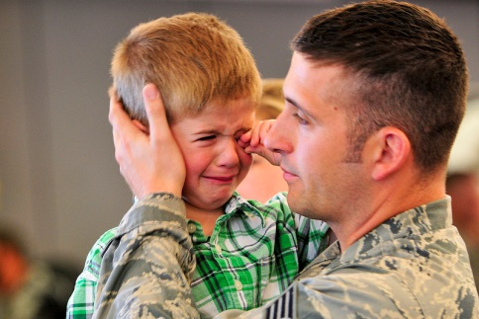

5. Star Spangled Kids Unit Award

Type of award: Citation Plaque
Presented to: One unit chairman in each division (5 overall awards)
Materials and guidelines:

- Awarded to the unit chairman in each division for the most outstanding program promoting “Star Spangled Kids.”
- Narrative not to exceed 1,000 words. Include specific examples of “Star Spangled Kids” activities and programs.
- May include pictures, news articles, news releases, etc.
- MUST attach an Award Cover Sheet found at the end of this program plan, including the name of the award, as well as the name and contact information for the unit Children & Youth Chairman.
- All entries MUST be received by May 1, 2018 by the Department Chairman.

*** Please remember that all of the above awards MUST include the 2017-2018 National Awards Cover Sheet ***

When submitting a National Award, please make arrangements in advance for the return of any materials.

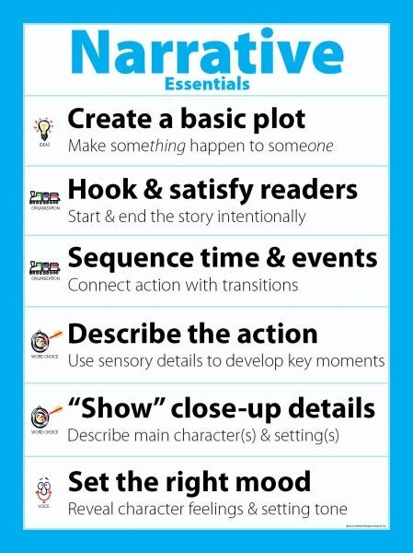

CHILDREN & YOUTH

DEPARTMENT AWARDS

1. Peggy Miller Award

Awarded to the Junior Auxiliary member who shows outstanding participation in one or more programs of the American Legion Auxiliary. Narrative is to be typed and submitted by a senior member of the junior’s unit on 8-1/2” by 11” white paper. Entry to be received by the Department Children and Youth Chairman thirty (30) days prior to Department Convention. Award will be presented at Department Convention.

2. Lois J. McFall Children & Youth Trophy

- Children & Youth Form must be submitted and include all required statistical information, i.e., money expended, number of children and families assisted, etc.
- Cash contributions must be made through Department to each of the following:

a) All Children’s Hospital
b) Mailman Center for Child Development
c) Beads of Courage
d) American Legion Child Welfare Foundation

- One special meeting on Children and Youth during the year, preferably in April.

A narrative of all Children and Youth projects and activities, not to exceed 1,000 words must be submitted. (Narrative will not contain statistical information since this is reported on the Children & Youth Form).

a) Unusual community projects for Children & Youth along with any service rendered in this area may be included.

b) Programs and cooperation with Post are very important and should be included.

c) Unit participation in community Children & Youth programs sponsored by other organizations may also be included.
d) General

1. Margins will be 1” on all sides. Pages will be numbered ½ “from the bottom, in the middle of the page. Narrative will be secured with a staple in upper left hand corner.
2. Cover page will include:

      - Unit Name and Number
      - Location
      - District
      - Year
      - Unit Children & Youth Chairman and Unit President’s name, address and signatures. This information will be centered on the cover page.

3. Heading will be used on first page only and will be 1” from the top with narrative beginning two spaces below heading. Heading will read “NARRATIVE – CHILDREN AND YOUTH PROGRAM (all capital letters).

4. Narrative will be typed on white bond, 8-1/2” by 11”, double spaced, in upper/lower case type.

5. Narrative to be received by the Department Chairman no later than thirty (30) days prior to Department Convention. Department Chairman will be assisted in judging by committee members or, at her discretion, other individuals she deems appropriate.

6. To qualify, statistical report (Unit Year-end Report) form must accompany narrative being submitted.

7. Special emphasis in judging will be given as to the size of Unit and accomplishments accordingly.

8. Judging will be based on the following:

      - Conciseness
      - Originality of Content
      - Neatness
      - Correct spelling, grammar and punctuation
      - Compliance with all above rules.

NOTE: In the interest of postage, no special cover or binder, special artistic designs or extras, such as pictures, will count in judging nor be required. These, in fact, are discouraged.

Chairman Award

Children’s Courage Award - Awarded to one Unit in each membership grouping that best promotes the Beads of Courage Carry a Bead Program. Units must submit a narrative, not to exceed 1,000 words, explaining how they supported and promoted this program. Narratives must be typed, using size 12, Times New Roman fonts. Narratives must be on white, 8-1/2” x 12” paper. Pictures may be included. Narrative shall include ideas, events, amount of money raised, along with number of Bead Kits sponsored. All entries shall be submitted to Department Chairman no later than May 1, 2018.

