American Legion Auxiliary
Membership Program Action Plan
2017-2018

For this coming year, President Treva Kay Wildrick's theme is “Catching Rays, Creating Brighter Futures”. She has chosen the rays emitted by the reflection from the sun on crystals as her logo. She is fascinated by the way Kaleidoscopes refract light and has decided to call the Department Newsletter, the Kaleidoscope.

We will use the movie “Mary Poppins” as the theme for our membership to help us create and sustain a brighter future with a positive attitude and a renewed sense of pride in our organization, our lives, and our friendships. As we renew, recruit, and rejoin members this year, let us use a spoonful of sugar to increase our membership and to give the current members we have a positive outlook on our mission.

We need to grow our organization in order to carry out our mission to assist veterans, military, and their families. In order to grow the organization, National says we must let members know that they are the Auxiliary's most valuable asset. We need to continue being a good example of Service Not Self and to work on our 5 year plan to attain a million members Nationally by our Centennial Anniversary in 2019.

To make it more convenient for members to transfer to another unit, National is making revisions that make it ok to transfer from one unit to the other without being voted on again and also with being able to pay back dues to the unit you are transferring to.

Membership is EVERYONE's Job!!!! Work together as a family. Carry your pack of membership applications with you everywhere you go.

Share your stories with us. Inspiration can be contagious!!!!

Don’t forget to promote our membership benefits. We have had many discounts, products, and services added and available to our members. Most recently, they have added a Bonus Drive program giving us a stress-free $500 Cash Rebate on purchasing or leasing a new vehicle from one of the nation’s leading auto manufacturers. Details are located at BonusDrive.com.

When you have achieved your individual or unit awards, especially the Recruit 10 or the Silver Brigade, please send them in as soon as possible. PLEASE DO NOT WAIT TILL THE END OF THE YEAR! The information sent in on these forms must be verified and if you wait too long, it may not be able to be possessed in time.
Thank You
Debbie Sviderskas
Department Membership Chairman
DEPARTMENT OF FLORIDA MEMBERSHIP COMMITTEE
2017-2018

DEPARTMENT CHAIRMAN
Debbie Sviderskas
2625 Quincy St. S.
Gulfport, FL 33711
(727) 686-2782
membershipchairman@alafl.org

NORTHERN AREA WESTERN AREA
Carolyn Brown Ive ”Nell” Hewit
5791 University Club Blvd. N. Unit 1312 4443 Argyle Lane
Jacksonville, FL 32277 Tallahassee, FL 32309
(904) 674-4179 (850)766-1909
northernareamembership@alafl.org westernareamembership@alafl.org

CENTRAL AREA EASTERN AREA
Katie Gabehart Dorothy Walsh
14210 85th Avenue 796 Cavalier Dr. Apt. A
Seminole, FL 33776 Indialantic, FL 32903
(727)804-3783 (321)426-6736
centralareamembership@alafl.org easternareamembership@alafl.org

SOUTHWESTERN AREA SOUTHERN AREA
Jackie Moody Denice Grinis
421 Clark Street 1248 SW 1st Ave.
Labelle, FL 33935 Pompano Beach, FL 33060
(863) 234-8692 (754)264-4388
southwesternareamembership@alafl.org southernareamembership@alafl.org

Sun Catching Critters

Department President: Mrs. Banks
Department Officers: Penguins
Department Staff: Butterflies
Past Department Presidents: Carousel Horses
Membership Chairman: Mary Poppins
Membership Committee: Crystal Sweets

District Chairmen: Service Dogs

District Presidents: Sun Catching Critters

District 1: Ducks
District 2: Hound Dogs
District 3: Chickens
District 4: Rabbits
District 5: Squirrels
District 6: Parrot
District 7: Lambs
District 8: Goose
District 9: Deer
District 11: Turtles
District 12: Fox
District 13: Robins
District 14: Horses
District 15: Pigeons
District 16: Cows
District 17: Pigs

Unit Members: Stars
Membership
GOALS
For the Department of Florida

August 15th----1/4th tsp. Full of Sugar Award
Submit 1st Transmittal to Department by this date

September 15th----1/3rd tsp. Full of Sugar Award
Submit 5th Transmittal to Department by this date

October 15th----1/2 tsp. Full of Sugar Award
50% of last year’s membership at close of books last year.

October 31st----NO GOOSE EGGS!!!! DISTRICT PRESIDENTS: IF YOU HAVE ANY UNITS WHO DO NOT HAVE ANY MEMBERSHIP SENT IN BY THIS DATE, YOU WILL HAVE TO WEAR A GOOSE DROPPINGS NECKLACE UNTIL YOU GET RID OF YOUR GOOSE EGGS!!!!

December 15th----2/3rd tsp. Full of Sugar Award
75% of last year’s membership at close of books last year.

January 15th----3/4th tsp. Full of Sugar Award
85% of last year’s membership at close of books last year.

February 15th----1 tsp. Full of Sugar Award
95% of last year’s membership at close of books last year.

March 15th----1 Cup Full of Sugar Award
100% of last year’s membership at close of books last year.

April 15th----Blue Ribbon of Sugar Award
105% of last year’s membership at close of books last year.

“The Admiral Boom Challenge”
Department Membership
Chairman's Acrostic phase
National Membership
Chairman's Acrostic phase
your text
your text

C---hallengingly
R---aise
E---xpectations
A---ttained
T---ogether
E---veryday
S—erving the mission
E---xellance
R---espect for all
V---alue our time
E---ngage our members
and community
Membership is
EVERYONE's
Job
Mary Poppins Challenges all units in the Department of Florida to be like Admiral Boom and Shoot off your Cannons. As Mr. Pinnacle loads up the cannon with “Catching Rays, Creating Brighter Futures”
Ammunition, we need to prepare our members to be recruiters for the American Legion Auxiliary.

Every Unit is to set up a table at any local community event (Example: farmers markets, craft fairs, festivals, parades, flea markets, etc.) and promote membership!!!

Invite Everyone in your Unit, Legion and SAL family!
Invite District Officers & Chairmen!
Invite Area Membership Chairman (Sugar Sweeps)!
Invite Department Officers & Chairmen!
Mrs. Banks and Mary Poppins might even show up if you invite them. Maybe even some department guide dogs or penquins.

Submit a story about your event along with photo's/articles to your local papers ASAP. Because each month two stories will be chosen to be featured in the department Kaleidoscope. All stories will also be sent on to National and who knows, you may find yourself featured in the National Magazine.

We would like to have the walls shake, all over the state, as your cannons are thunderingly emphasizing our message of “Service not Self”

Membership Reporting

Mid-Year Reports
Mid-year reports reflect the program work of units in the department. Each department membership chairman is required to submit a narrative report by January 5, 2018, to the division membership chairman at her address found on the front page of this program Plan, along with a copy to the national membership chairman.

Year-End Reports
Annual reports reflect the program work of units in the department. Each department membership chairman is required to submit a narrative report by May 15, 2018, to the division membership chairman at her address found on the front page of this program Plan, along with a copy to the national membership chairman. Members and units should follow their department’s protocol and deadlines.

In order for your Department Chairman to submit the above mid-year report, I need the units to submit their enclosed report by the date on the form to your District Chairman and for the District Chairman to collect them and send me your report by the date on your enclosed form. This is a Mid-Year Report ONLY. What they request for the End of the Year is Department information. Thank You in Advance.

National Membership Awards

A. Member Award: Rejoin 1
Guidelines: Rejoin 1 FORMER Auxiliary Junior or senior member (must not have paid dues after 2015). Submit Rejoin 1 form to National Headquarters by May 1, 2018, to receive a Rejoin 1 pin. All verified entries will be eligible for $100 cash drawing. Note: One entry per recruiter.

B. Member Award: Recruit 1
Guidelines: Recruit 1 NEW Auxiliary Junior or senior member. Submit Recruit 1 form to National Headquarters by May 1, 2018, to receive a Recruit 1 pin. All verified entries will be eligible for $100 cash drawing. Note: One entry per recruiter.

C. Member Award: Recruit 10
Guidelines: Recruit 10 or more NEW Auxiliary Junior or senior members. Submit form to National Headquarters by May 1, 2018, to receive an ALA microfiber cleaning cloth for your cellphone and electronic screens. All verified entries will be eligible for $250 cash drawing. Note: One entry per recruiter.

D. Member Award: Silver Brigade Guidelines:
Recruit 25 or more NEW SENIOR Auxiliary members to receive a special gift from the national president. Entry forms must be received at National Headquarters by May 1, 2018, in order to qualify. All verified entries will be eligible for a $500 cash drawing. Note: One gift per recruiter.

E. Unit Award: Best Member Experience
Guidelines: Units that demonstrate the most effective way(s) to improve the member experience must complete the Best Member Experience Award form. Units submitting the Best Member Experience Award form are eligible to receive a letter from the national president, recognition in Auxiliary magazine and at national convention, and $100 to be used for membership and mission outreach.

Units must submit completed Best Member Experience Award form to your department Membership chairmen. Department Membership chairmen are to submit completed forms to their national division Membership chairman by May 1, 2018. The National Membership Committee will select one winner per division.

DEPARTMENT AWARDS:

Each Membership Goal Listed will receive a spoon pin fashioned especially for that goal.

1/4th tsp. Full of Sugar Award---Yellow

1/3rd tsp. Full of Sugar Award---Green

1/2 tsp. Full of Sugar Award---Pink

2/3rd tsp. Full of Sugar Award---Purple

3/4th tsp. Full of Sugar Award---Blue

1 tsp. Full of Sugar Award---White

1 Cup Full of Sugar Award---Special measuring cup pin

Blue Ribbon of Sugar Award---A Blue Ribbon to attach to the measuring cup pin

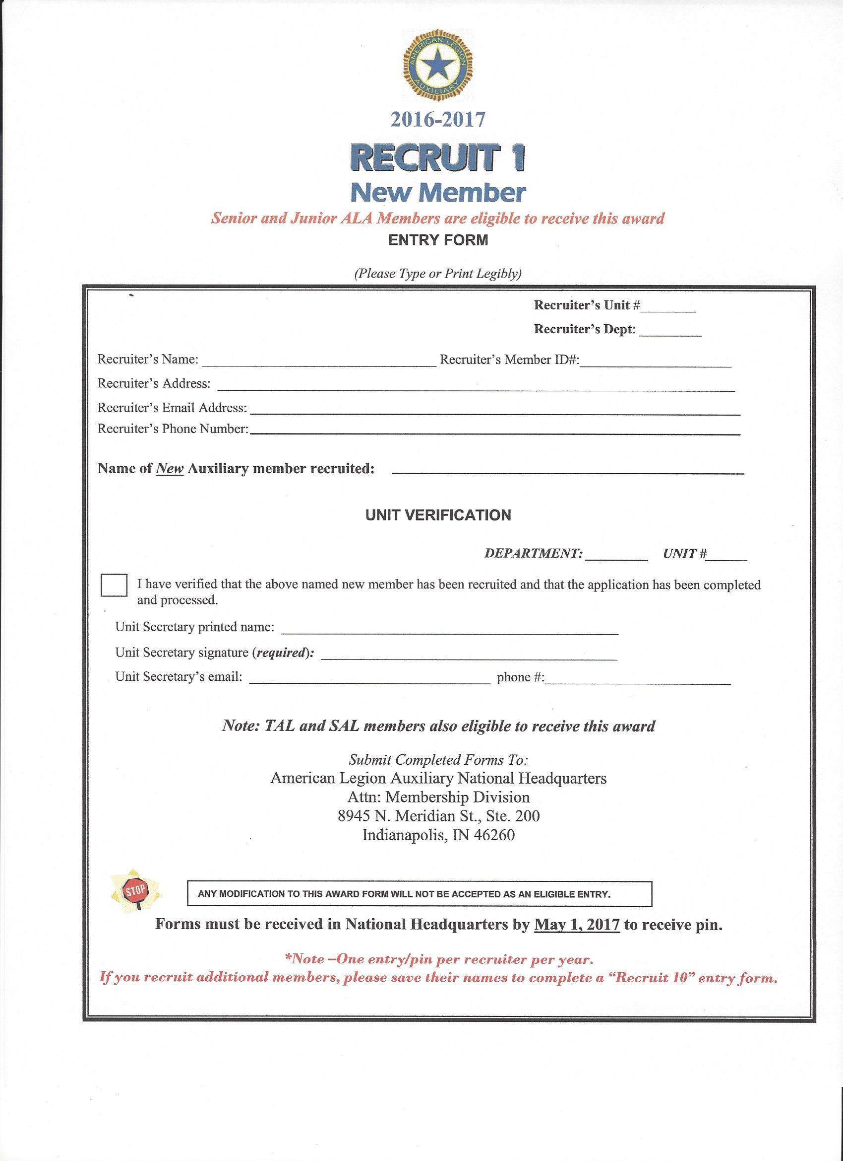
2017-2018

20201
[Cite your source here.]

May 1, 2018

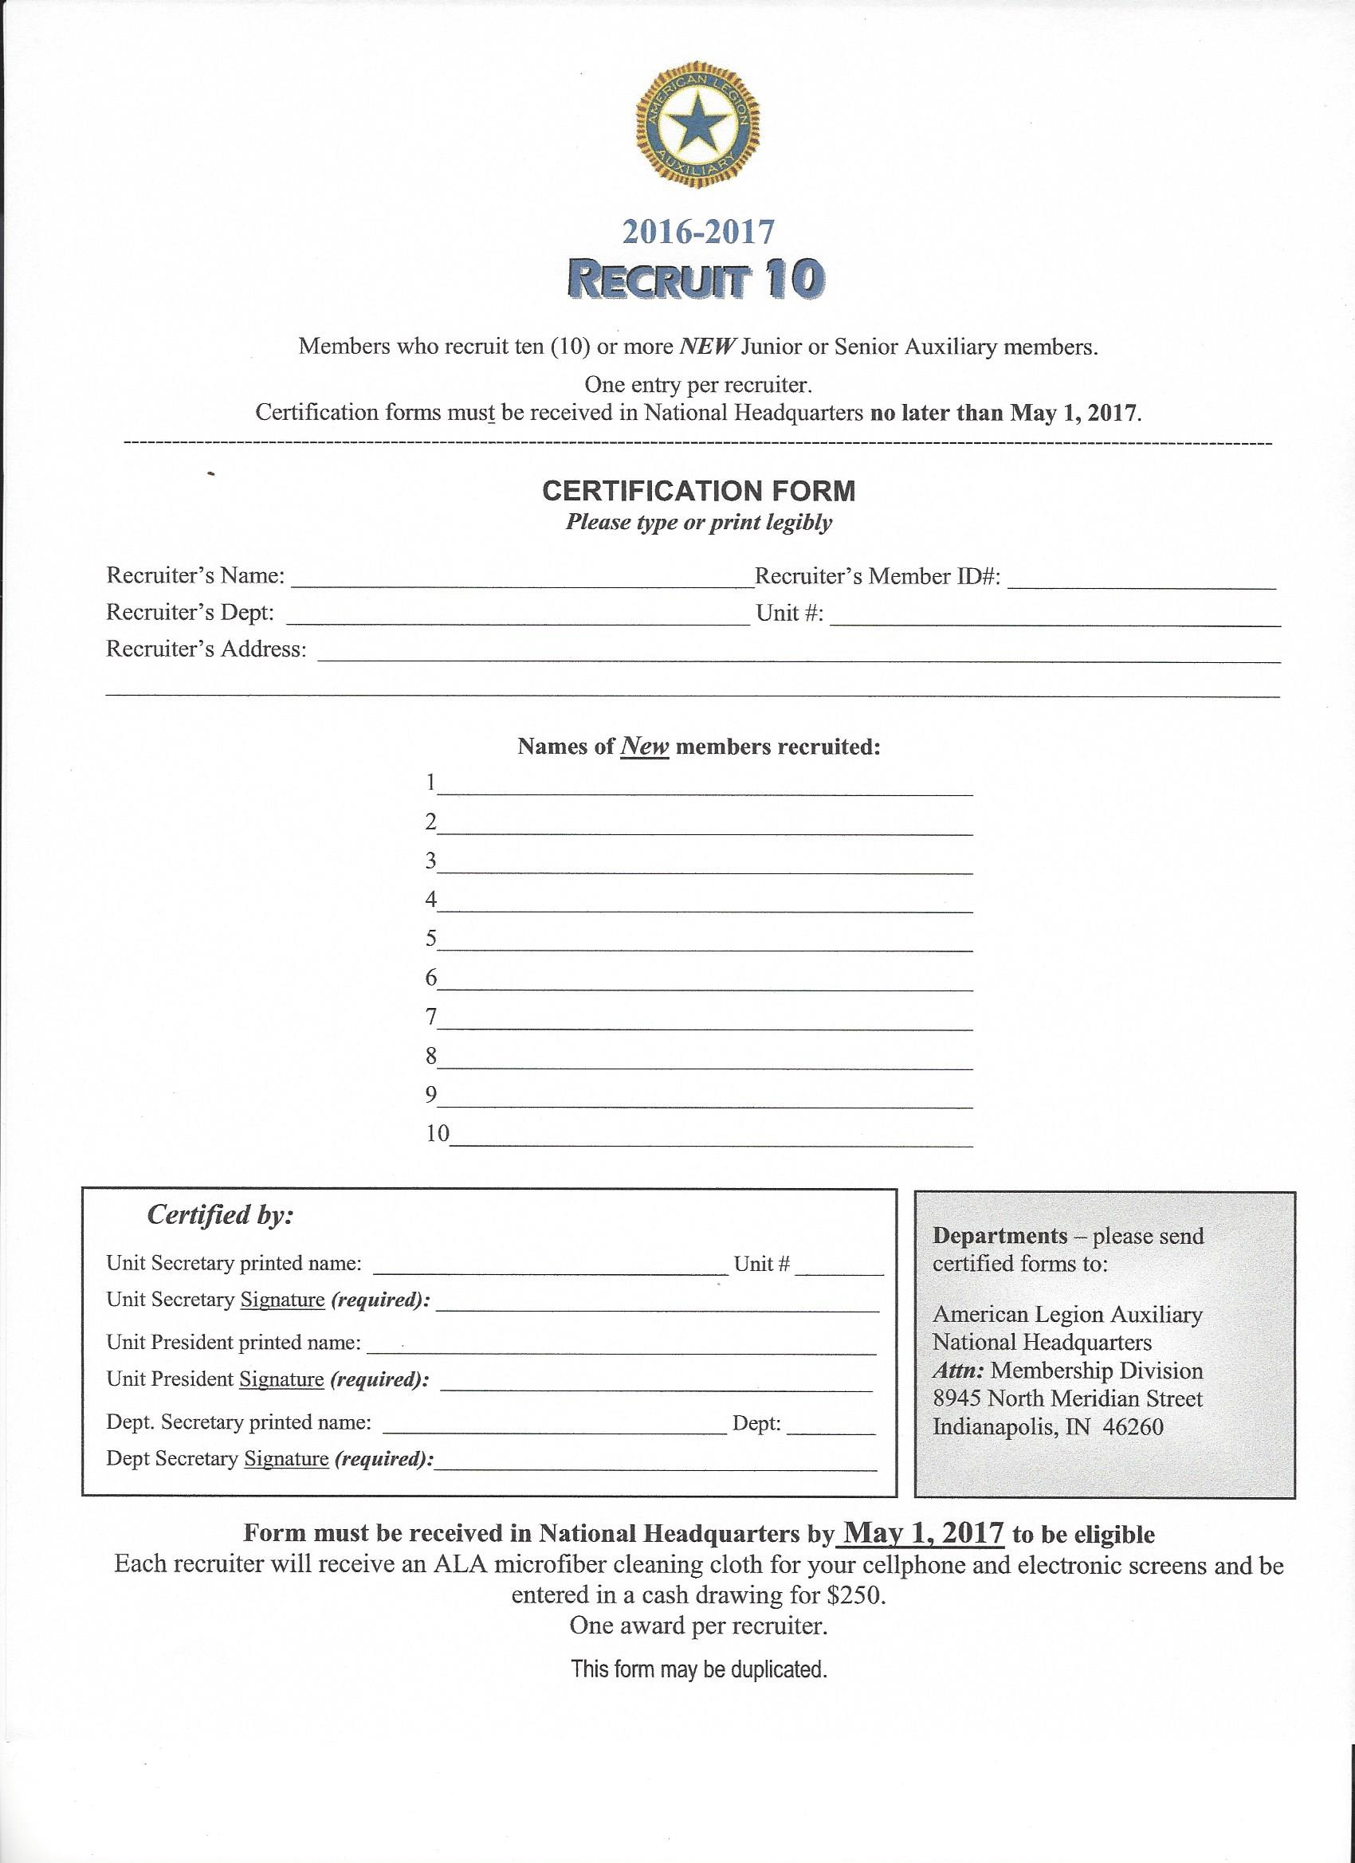

2017-2018
May 1, 2018
May 1, 2018
May 1, 2018
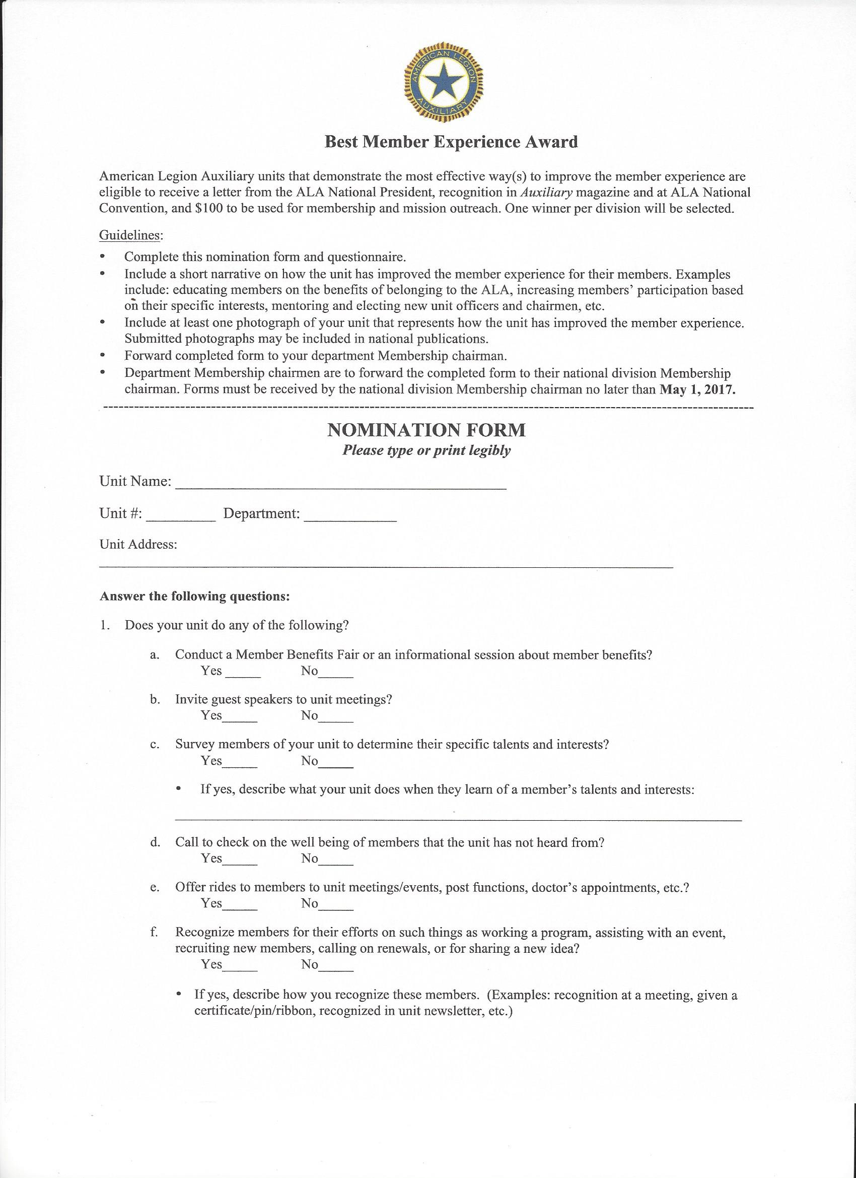
May 1, 2018
May 1, 2018
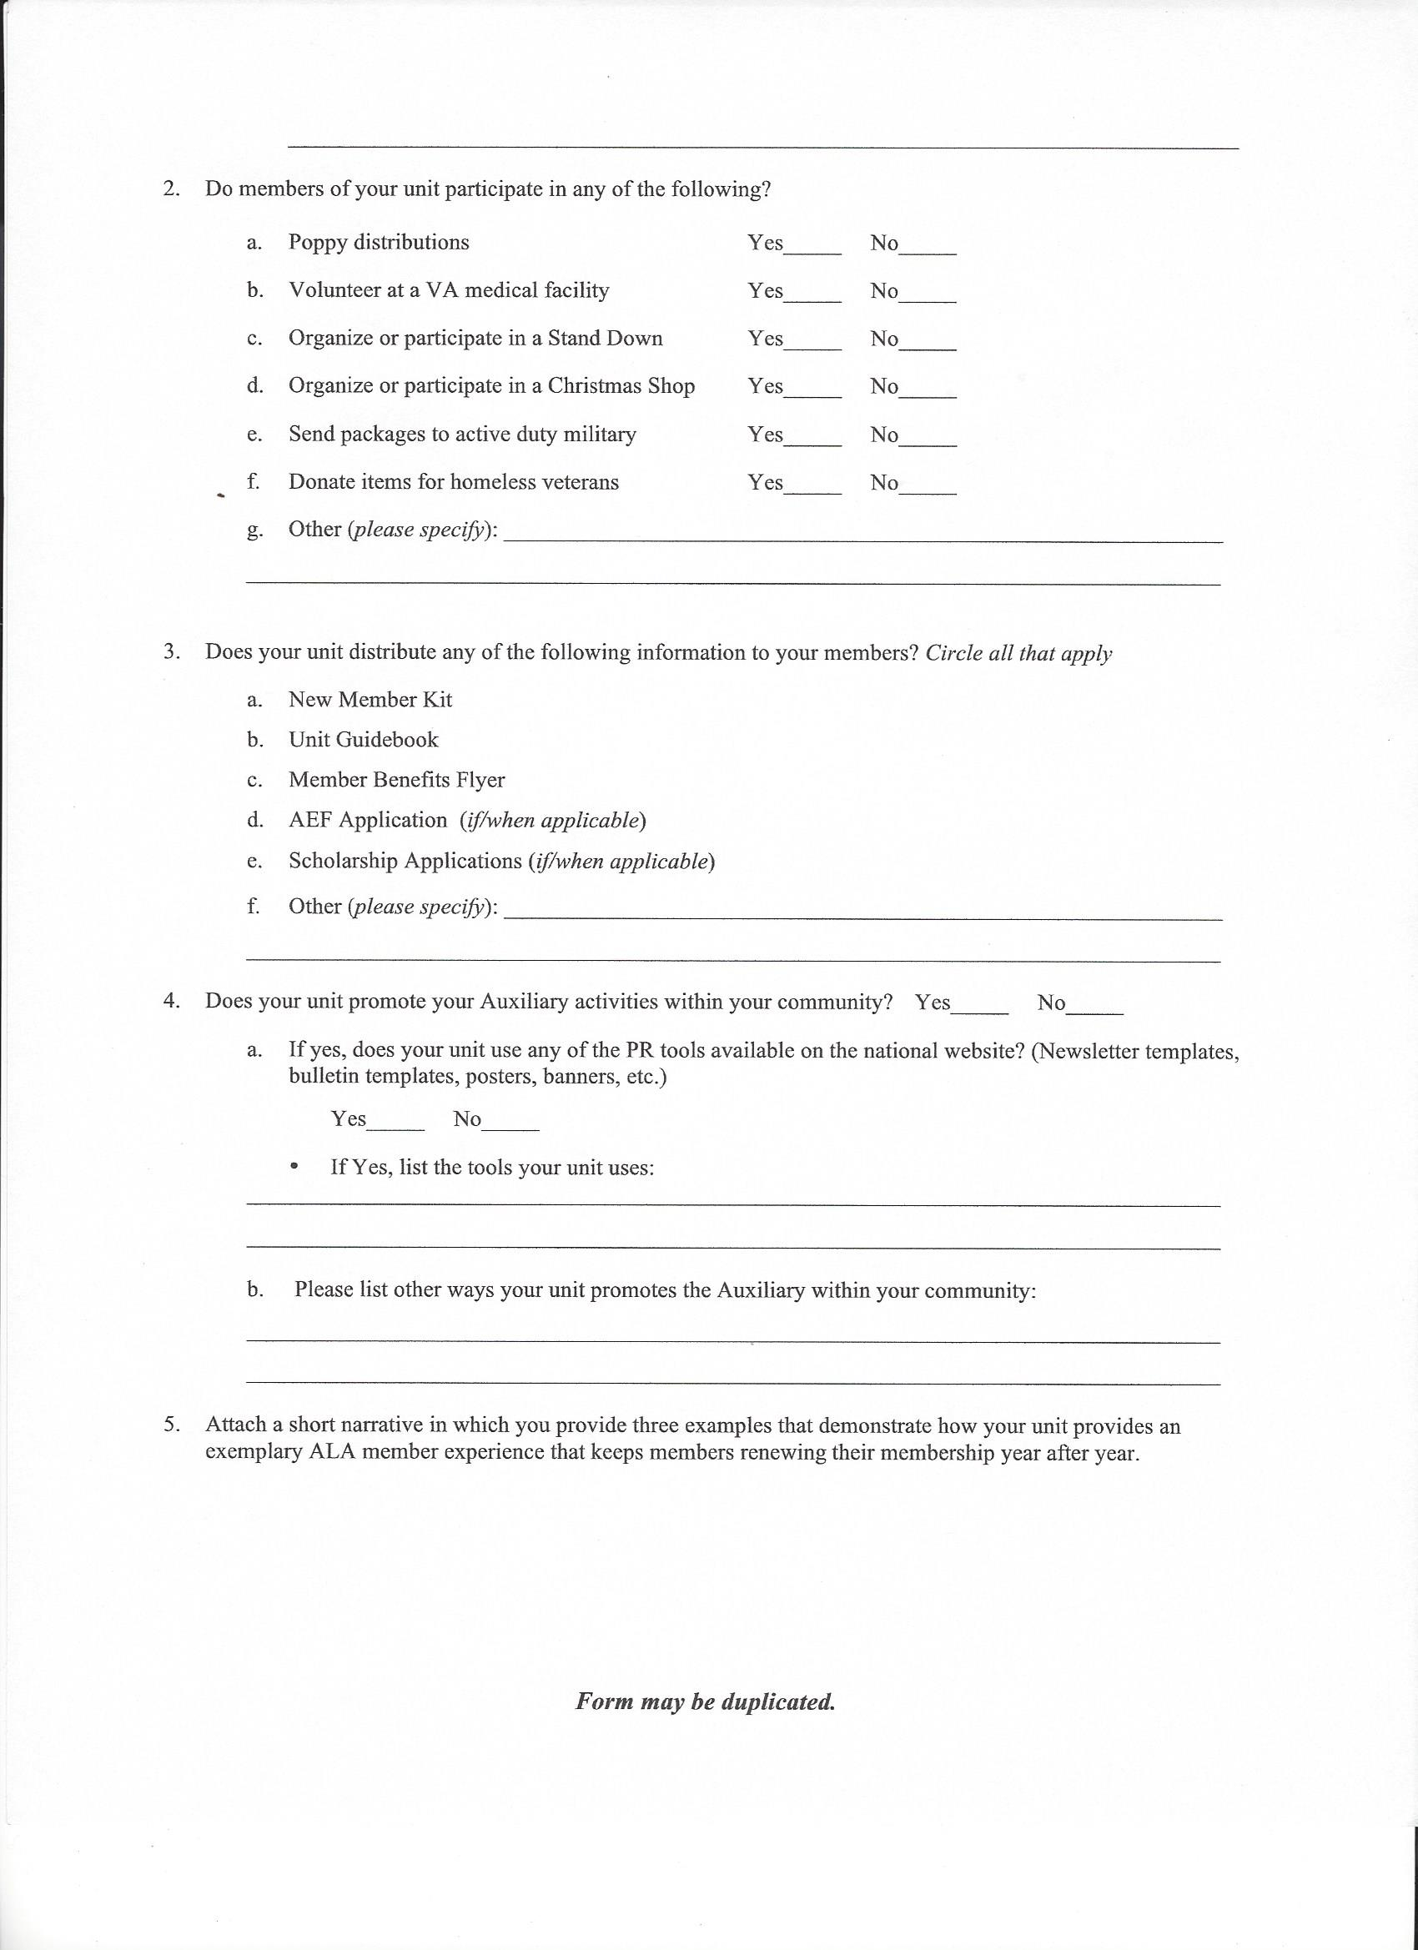
Creating Brighter Futures---Unit Mid-Year
Membership
Unit Name:_______________________________________Unit #:____________
Chairman Name:____________________________________________________
Address:___________________________________________________________
Phone #:___________________E-mail___________________________________

How have you created a brighter future for your members so far this year? PLEASE Share your stories with me for my mid-term report to National by answering the following questions. Attach a separate sheet if more room is needed. No more than 50 words please.

1. Provide an example of how your unit is encouraging renewals: _________________________________________________________________________________________________________________________________________________________________________________________________________
___________________________________________________________________

2. Did working any of the ALA programs help to generate new members? (Example: Teaching flag etiquette at school resulted in two teachers joining the ALA) ______________________________________________________________________________________________________________________________________
______________________________________________________________________________________________________________________________________

3. Have you implemented new/innovative ideas or practices to increase renewals and/or sign up new members? If so what are they?
_________________________________________________________________________________________________________________________________________________________________________________________________________
___________________________________________________________________

Your Report is Due to your District Chairman by November 15th, 2017

THERE IS NO END OF THE YEAR REPORT!!!
Creating Brighter Futures---District Mid-Year
Membership
District #:___________________________________________________________
Chairman Name:____________________________________________________
Address:___________________________________________________________
Phone #:___________________E-mail___________________________________

How have you created a brighter future for your members so far this year? PLEASE Share your stories with me for my mid-term report to National by answering the following questions. Attach a separate sheet if more room is needed. No more than 50 words please.

1. Provide an example of how your units are encouraging renewals: _________________________________________________________________________________________________________________________________________________________________________________________________________
___________________________________________________________________

2. Did working any of the ALA programs help to generate new members? (Example: Teaching flag etiquette at school resulted in two teachers joining the ALA) ______________________________________________________________________________________________________________________________________
______________________________________________________________________________________________________________________________________

3. Have any of your units’ implemented new/innovative ideas or practices to increase renewals and/or sign up new members? If so what are they?
_________________________________________________________________________________________________________________________________________________________________________________________________________
___________________________________________________________________
Your Report is Due to your Department Chairman by December 1st, 2017
Debbie Sviderskas, 2625 Quincy St. S., Gulfport, FL 33711,
727-686-2782

THERE IS NO END OF THE YEAR REPORT!!!
membershipchairman@alafl.org

